

**COMPANY PROFILE**

|  |  |  |  |  |  |  |  |  |  |  |
| --- | --- | --- | --- | --- | --- | --- | --- | --- | --- | --- |
|  |  |  |  |  |  |  |  |  |  |  |

|  |  |  |  |  |  |  |  |  |  |  |
| --- | --- | --- | --- | --- | --- | --- | --- | --- | --- | --- |
|  |  |  |  |  |  |  |  |  |  |  |

|  |  |  |  |  |  |  |  |  |  |  |
| --- | --- | --- | --- | --- | --- | --- | --- | --- | --- | --- |
|  |  |  |  |  |  |  |  |  |  |  |

|  |  |  |  |  |  |  |  |  |  |  |
| --- | --- | --- | --- | --- | --- | --- | --- | --- | --- | --- |
|  |  |  |  |  |  |  |  |  |  |  |

|  |  |  |  |  |  |  |  |  |  |  |
| --- | --- | --- | --- | --- | --- | --- | --- | --- | --- | --- |
|  |  |  |  |  |  |  |  |  |  |  |

|  |  |  |  |  |  |  |  |  |  |
| --- | --- | --- | --- | --- | --- | --- | --- | --- | --- |
|  |  | **L’AZIENDA** |  |  | **LA PRODUZIONE** |  |  | **RICERCA E SVILUPPO** |  |

|  |  |  |  |  |  |  |  |  |  |
| --- | --- | --- | --- | --- | --- | --- | --- | --- | --- |
|  | 2 |  |  | 4 |  |  | 6 |  |  |

|  |  |  |  |  |  |  |  |  |  |
| --- | --- | --- | --- | --- | --- | --- | --- | --- | --- |
|  |  | **THE COMPANY** |  |  | **PRODUCTION** |  |  | **RESEARCH AND** |  |

|  |  |  |  |  |  |  |  |  |  |
| --- | --- | --- | --- | --- | --- | --- | --- | --- | --- |
|  |  |  |  |  |  |  |  | **DEVELOPMENT** |  |

|  |  |  |  |  |  |  |  |  |  |  |
| --- | --- | --- | --- | --- | --- | --- | --- | --- | --- | --- |
|  |  |  |  |  |  |  |  |  |  |  |

|  |  |  |  |  |  |  |  |  |  |  |
| --- | --- | --- | --- | --- | --- | --- | --- | --- | --- | --- |
|  |  |  |  |  |  |  |  |  |  |  |

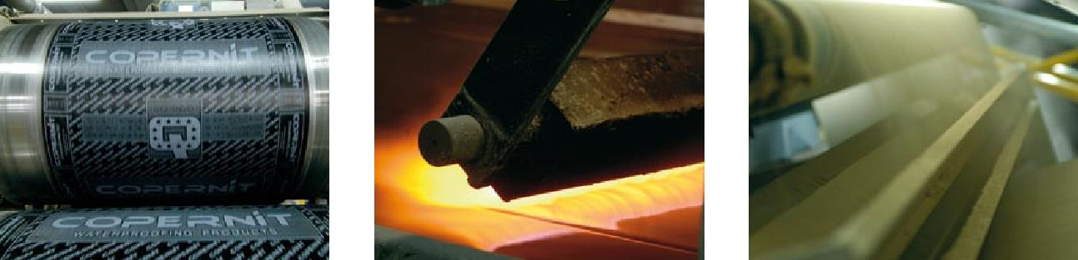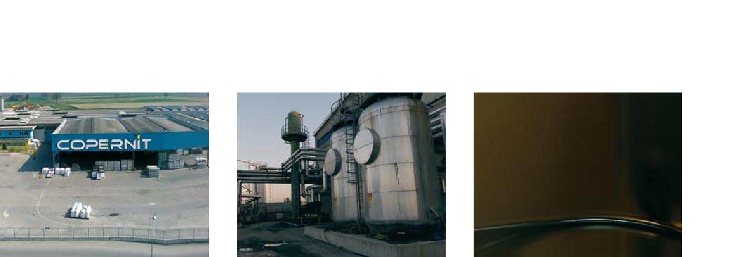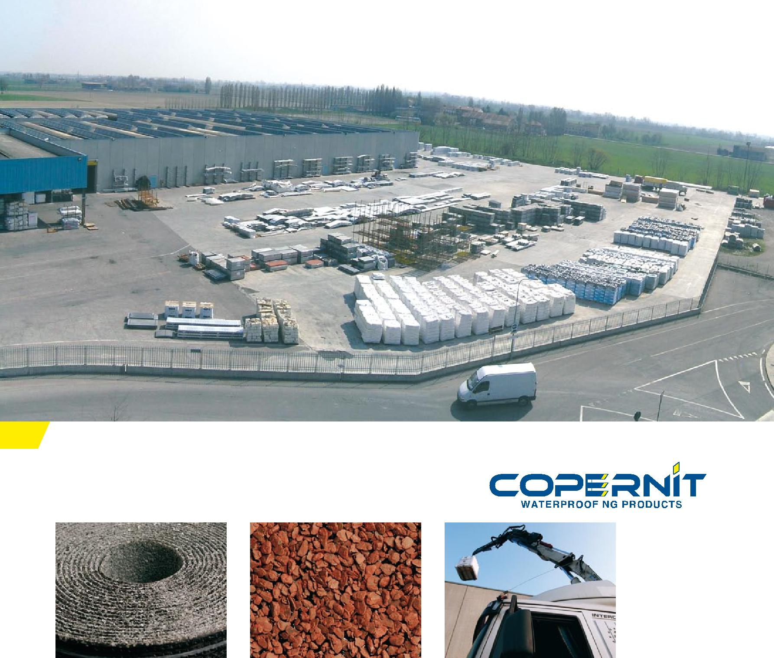

|  |  |  |  |  |  |  |  |  |  |  |  |  |  |
| --- | --- | --- | --- | --- | --- | --- | --- | --- | --- | --- | --- | --- | --- |
|  |  |  |  |  |  |  |  |  |  |  |  |  |  |

|  |  |  |  |  |  |  |  |  |  |  |  |  |  |
| --- | --- | --- | --- | --- | --- | --- | --- | --- | --- | --- | --- | --- | --- |
|  |  |  |  |  |  |  |  |  |  |  |  |  |  |

|  |  |  |  |  |  |  |  |  |  |  |  |  |  |
| --- | --- | --- | --- | --- | --- | --- | --- | --- | --- | --- | --- | --- | --- |
|  |  |  |  |  |  |  |  |  |  |  |  |  |  |

|  |  |  |  |  |  |  |  |  |  |  |  |  |  |
| --- | --- | --- | --- | --- | --- | --- | --- | --- | --- | --- | --- | --- | --- |
|  |  |  |  |  |  |  |  |  |  |  |  |  |  |

|  |  |  |  |  |  |  |  |  |  |  |  |  |  |
| --- | --- | --- | --- | --- | --- | --- | --- | --- | --- | --- | --- | --- | --- |
|  |  |  |  |  |  |  |  |  |  |  |  |  |  |

|  |  |  |  |  |  |  |  |  |  |  |  |  |  |
| --- | --- | --- | --- | --- | --- | --- | --- | --- | --- | --- | --- | --- | --- |
|  |  |  |  |  |  |  |  |  |  |  |  |  |  |

|  |  |  |  |  |  |  |  |  |  |  |  |  |  |
| --- | --- | --- | --- | --- | --- | --- | --- | --- | --- | --- | --- | --- | --- |
|  |  |  |  |  |  |  |  |  |  |  |  |  |  |

|  |  |  |  |  |  |  |  |  |  |
| --- | --- | --- | --- | --- | --- | --- | --- | --- | --- |
|  |  | **I PRODOTTI** |  |  | **LE FINITURE** |  |  | **SERVIZIO E ASSISTENZA** |  |

|  |  |  |  |  |  |  |  |  |  |
| --- | --- | --- | --- | --- | --- | --- | --- | --- | --- |
|  | 8 |  |  | 13 |  |  | 16 |  |  |

|  |  |  |  |  |  |  |  |  |  |
| --- | --- | --- | --- | --- | --- | --- | --- | --- | --- |
|  |  | **PRODUCTS** |  |  | **FINISHES** |  |  | **SERVICE AND** |  |

|  |  |  |  |  |  |  |  |  |  |
| --- | --- | --- | --- | --- | --- | --- | --- | --- | --- |
|  |  |  |  |  |  |  |  | **ASSISTANCE** |  |

|  |  |  |  |  |  |  |  |  |  |  |  |  |  |
| --- | --- | --- | --- | --- | --- | --- | --- | --- | --- | --- | --- | --- | --- |
|  |  |  |  |  |  |  |  |  |  |  |  |  |  |

|  |  |  |  |  |  |  |  |  |  |  |  |  |  |
| --- | --- | --- | --- | --- | --- | --- | --- | --- | --- | --- | --- | --- | --- |
|  |  |  |  |  |  |  |  |  |  |  |  |  |  |

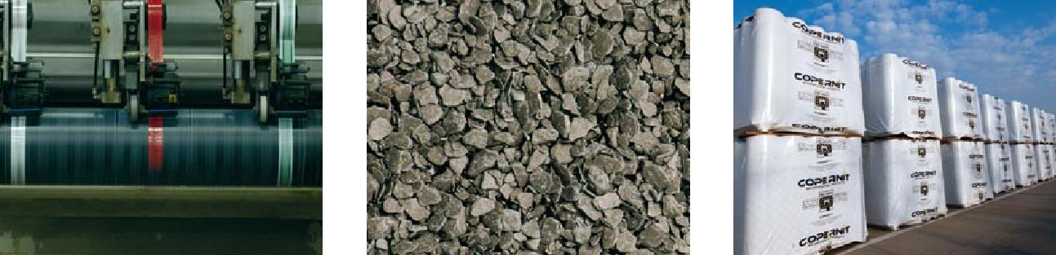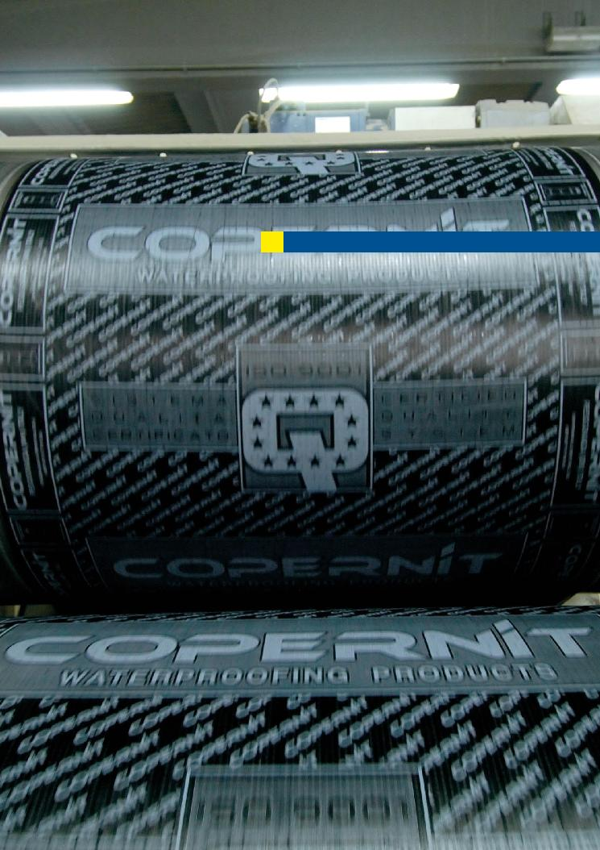

Conosciuti ed apprezzati in più di 40 paesi del mondo

2

Known and appreciated in over 40 countries throughout the world

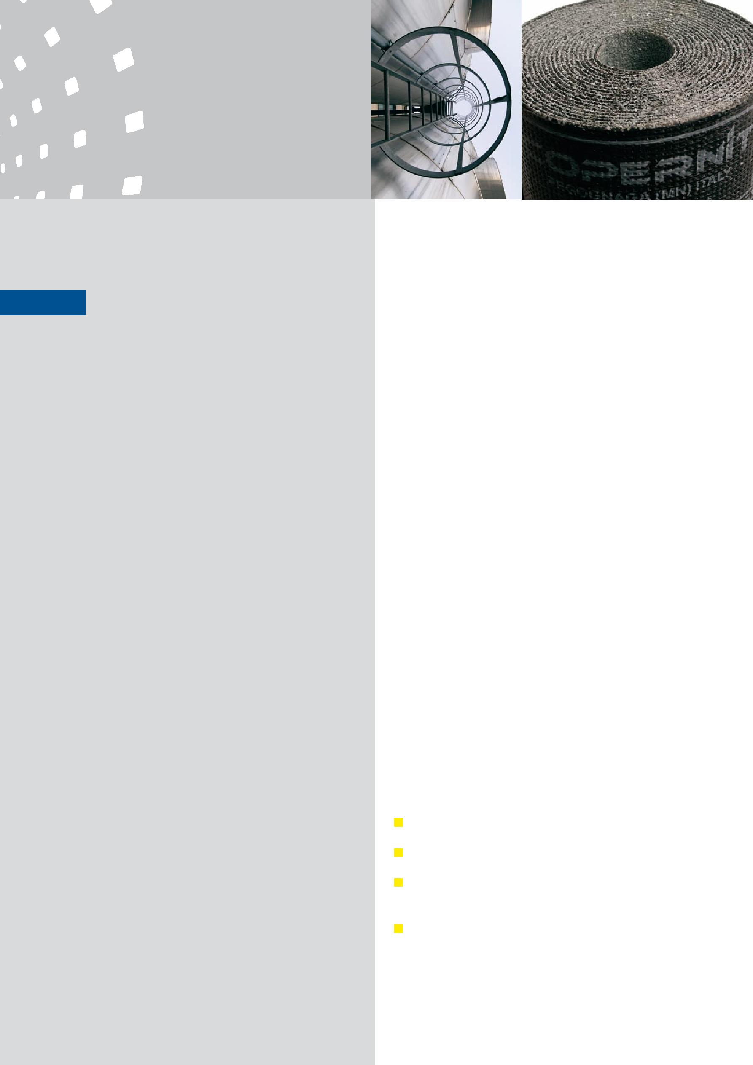

1. **L’AZIENDA THE COMPANY**

**Copernit S.p.A.** da oltre trenta anni, raccoglie l’esperienzanella produzione dei materiali impermeabilizzanti. Durante lo sviluppo, la società Copernit S.p.A. ha progettato e perfezionato differenti sistemi di impermeabilizzazione e attualmente propone una vasta gamma di membrane bituminose e accessori.

Grazie alla propria struttura organizzativa di produzione e vendita i prodotti Copernit sono conosciuti, apprezzati ed utilizzati da applicatori, progettisti e utenti finali in più di 40 paesi del mondo.

Le significative presenze nazionali ed internazionali di Copernit sono possibili grazie agli elevati standard qualitativi delle membrane bituminose Copernit, che le hanno consentito di ottenere importanti certificazioni di prodotto e di sistema in molti paesi del mondo.

Copernit per la distribuzione dei suoi prodotti prepara un team specializzato che non offre semplicemente il prodotto, ma un completo sistema di impermeabilizzazione. Alla disponibilità di membrane bituminose in grado di soddisfare le più diverse condizioni applicative e climatiche Copernit affianca una serie completa di accessori ed elementi necessari per la loro corretta posa e predispone un servizio gratuito, come:

consulenza in materia;



perizia sui cantieri;



scelta delle adeguate soluzioni tecniche e dei materiali idonei;



soluzioni ai problemi specifici.



**Copernit S.p.A.** has over 30 years experience in theproduction of waterproofing materials. Copernit S.p.A. has designed and developed different systems of waterproofing and now provides a comprehensive range of bituminous membranes and accessories.

Thanks to the organizational structure of its production department, Copernit products are known, appreciated and used by roofers, designers and end users in over 40 countries.

The significant national and international presence of Copernit is possible thanks to the high quality standards of Copernit bituminous membranes, which have enabled the company to acquire important product and system certifications in numerous countries throughout the world.

Copernit prepares a specialised team for the distribution of its products, not only offering simply the product, but also a complete system of waterproofing. Copernit flanks the availability of bituminous membranes capable of satisfying the most varied application and climatic conditions with a complete range of accessories and elements for their correct installation, also offering the following free services:

advice;

on-site surveys;

choice of adequate technical solutions and suitable materials;

solutions to specific problems.

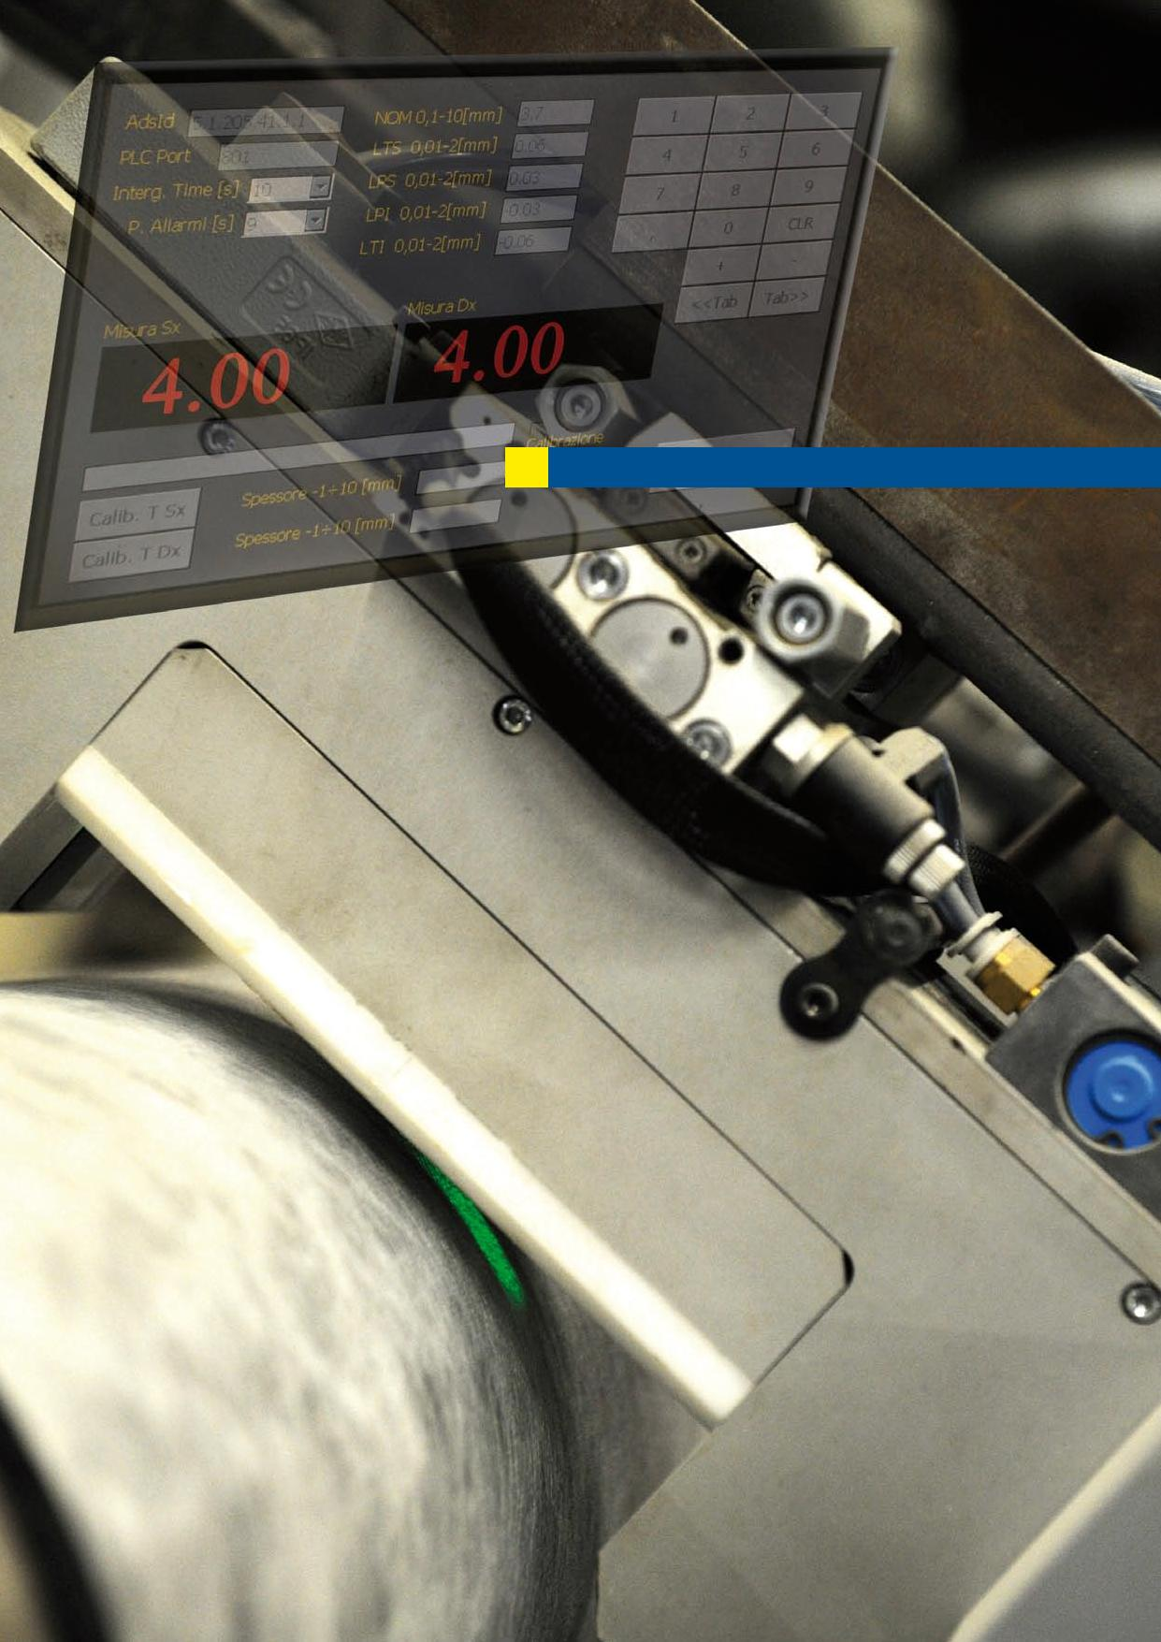

Moderne tecnologie

4

Advanced technologies



1. **LA PRODUZIONE PRODUCTION**

**Copernit S.p.A.** con l’evoluta tecnologia e con lemoderne linee di produzione garantisce un elevato standard di qualità delle membrane bituminose, che vengono utilizzate nei sistemi impermeabilizzanti in edilizia civile, industriale e in opere stradali (parcheggi, ponti, viadotti). Grazie ad attenti programmi di investimento in tecnologia e attraverso rigorose procedure di gestione della manutenzione, Copernit rende le proprie linee di produzione capaci di produrre con elevati standard qualitativi senza compromettere flessibilità e produttività. La gamma produttiva Copernit comprende membrane a base di bitume distillato modificato con polimeri plastomerici (genericamente classificate come “APP”, abbreviazione di Polipropilene Atattico, ma in realtà costituite da miscele di poliolefine più complesse e selezionate) oppure modificato con polimeri elastomerici (classificate genericamente come “SBS”, dal nome della gomma sintetica maggiormente utilizzata, a base di macromolecole di Stirene–Butadiene-Stirene) con supporti in:

velo di vetro rinforzato;



tessuto non tessuto di poliestere a fibra corta (fiocco) stabilizzato e rinforzato;



tessuto non tessuto di poliestere a fibra lunga (filo continuo) stabilizzato e rinforzato;



doppia armatura ottenuta dall’accoppiamento di tessuto non tessuto di poliestere e velo di vetro (sistema “biarmato”);



tessuto non tessuto composito, costituito da combinazioni di fibre di materiali diversi e rinforzi particolari;



armature per usi speciali, come lamine di alluminio, tessuti di vetro o accoppiati tecnici.



Le membrane possono essere rifinite sulla faccia superiore con talco, sabbia, films di Polietilene o Polipropilene, tessuto non tessuto di Polipropilene (finitura TEX) oppure autoprotette con scaglie di ardesia in diversi colori.

With state of the art technology and modern manufacturing plants, Copernit S.p.A. guarantees high quality bituminous membranes for use in waterproofing systems in civil and industrial buildings and road works (car parks, bridges, viaducts). Thanks to attentive programs of technological investment and strict maintenance management programs Copernit is able to manufacture its products in compliance with high quality standards without affecting flexibility and productivity. The Copernit product range includes modified distilled bitumen membranes with plastomeric polymers (usually classified as “APP” - atactic polypropylene, but actually made up of more complex and selected polyolefinic mixtures) or modified with elastomeric polymers (usually classified as “SBS”, from the name of the synthetic rubber most commonly used, consisting of macromolecules of Styrene-Butadiene-Styrene) with supports made of:

reinforced fibreglass;

non-woven short-fibre polyester (staple) reinforced and stabilized;

non-woven long-fibre polyester (spunbond) reinforced and stabilized;

double reinforcement obtained from the combination of non-woven polyester plus fibreglass (“biarmato” system);

non-woven composite polyester obtained from the combination of fibres of different materials and special reinforcements;

reinforcements for special applications as aluminium foils or technical couplings.

The upper surface of the membranes can be finished with talc, sand, PE or PP films, polypropylene non-woven fabric (“TEX” finish) or with self-protection with flakes of slate in different colours.

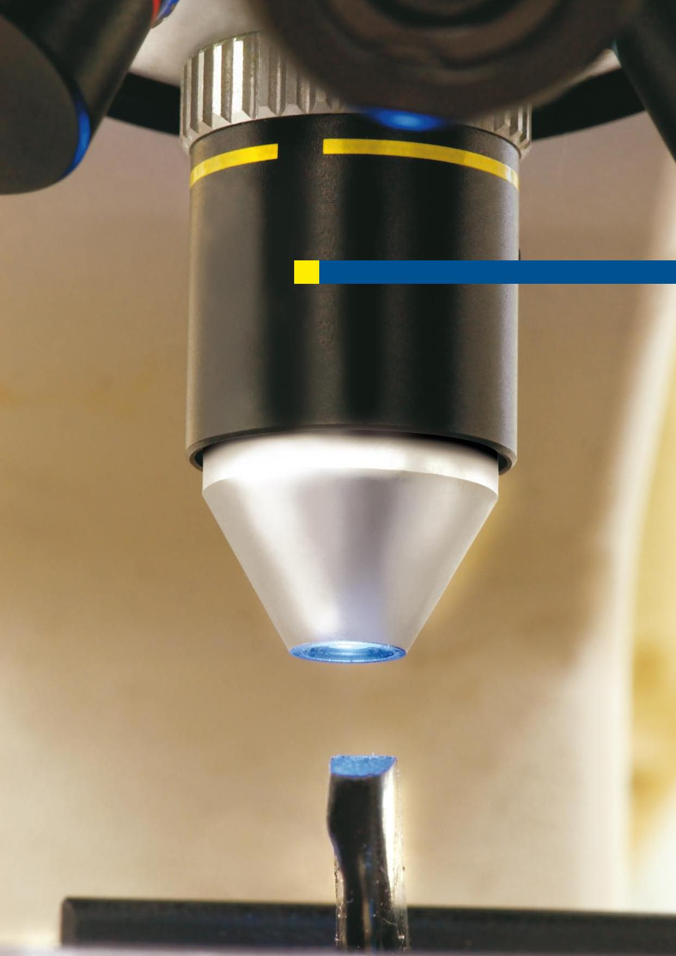

Continuo controllo del processo produttivo

6

Continuous control of the production process

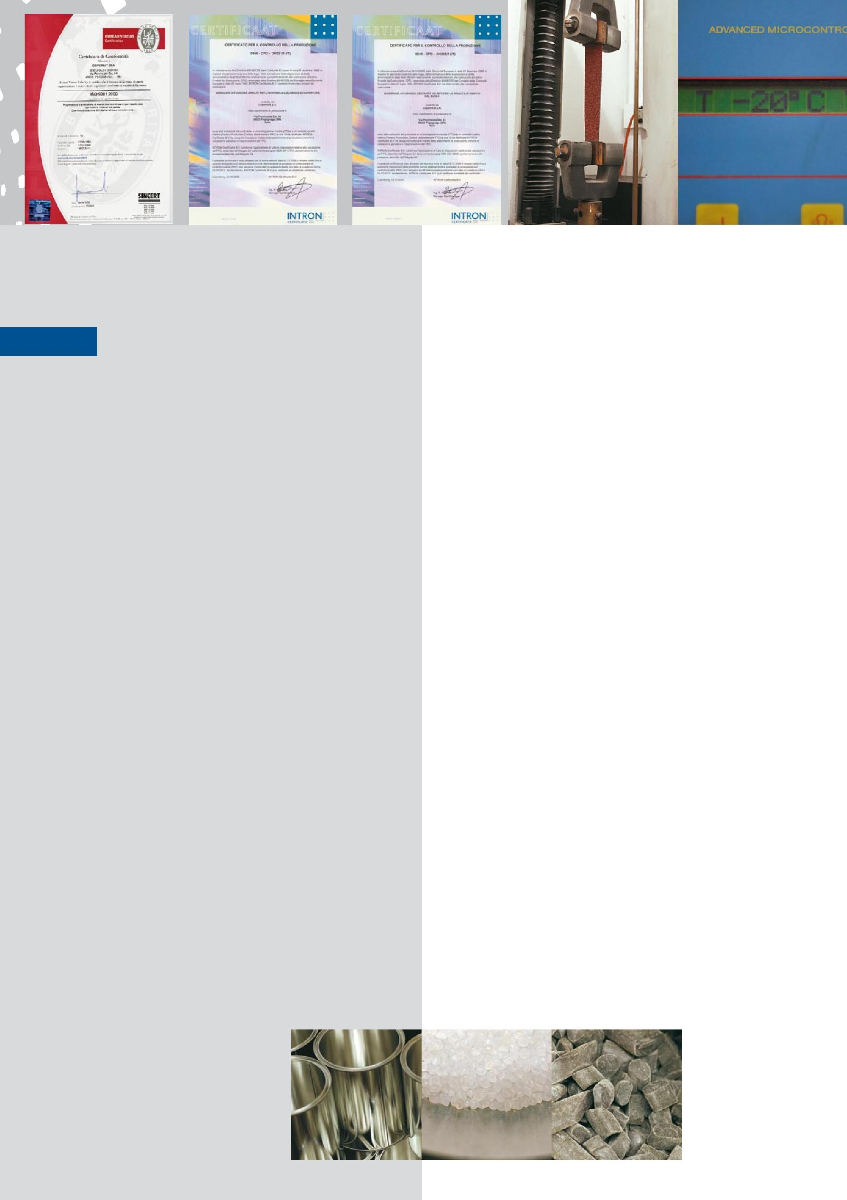

1. **RICERCA E SVILUPPO RESEARCH AND DEVELOPMENT**

La qualità dei prodotti Copernit e la loro lunga durata nel tempo è garantita da un continuo controllo dei materiali e del processo produttivo. I laboratori interni Copernit, dotati delle più complete strumentazioni, verificano costantemente la rispondenza dei prodotti e delle loro prestazioni agli standard qualitativi stabiliti.

Tutte le operazioni di controllo si svolgono con modalità e tempi definiti da una rigida procedura che comprende la verifica della qualità delle materie prime, il controllo dei parametri di produzione, fino alle modalità di carico e spedizione del prodotto finito. Il sistema di controllo della qualità assicura il rispetto di tutti i parametri dichiarati dal produttore, come richiesto dalla legislazione europea vigente (marcatura CE dei prodotti da costruzione).Il Sistema Qualità di Copernit SpA è strutturato e certificato in conformità alla norma UNI EN ISO 9001.

Progettazione e sviluppo di nuovi materiali e di nuove tecnologie produttive costituiscono per Copernit lo strumento fondamentale per raggiungere la soddisfazione dei propri Clienti e affrontare con successo le sfide del mercato globale.

Continuous control of the production process and materials ensures the high quality and long-lasting performance of Copernit products.

Copernit’s fully equipped in-house laboratories ensure the compliance of the products and their performances to the Quality Standards established.

All control operations are performed following strict procedures, with quality checks on raw materials, production parameters, right through to the finished product loading and dispatch phases.

The quality control system ensures the respect of all the parameters declared by the manufacturer, as required by current European legislation (CE marking for construction products). The Copernit S.p.A. Quality System is certified in compliance with UNI EN ISO 9001.

Design and development of new materials and new production technologies are, for Copernit, the fundamental instrument for achieving customer satisfaction and successfully facing global market challenges.

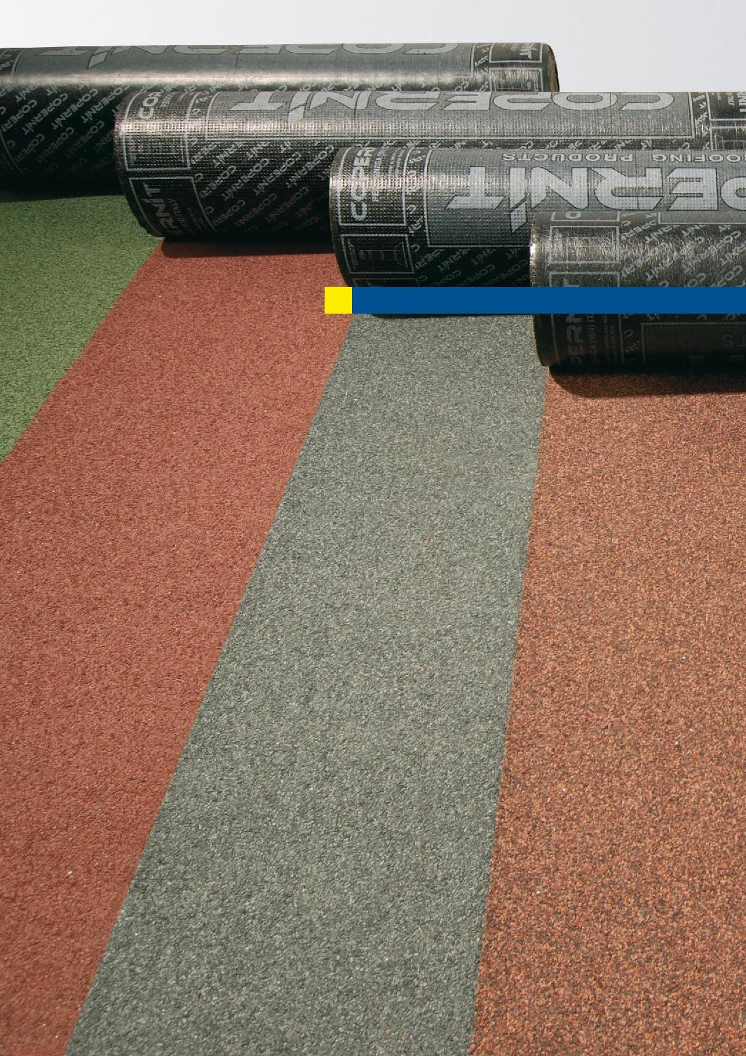

8

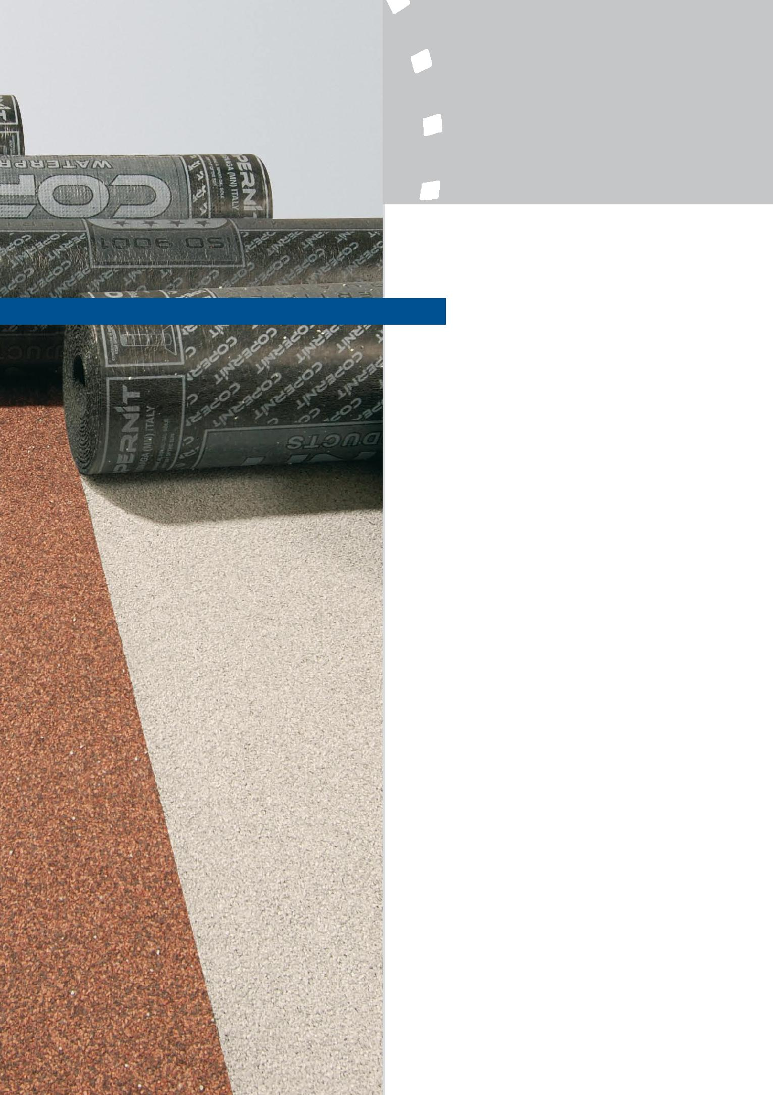

1. **I PRODOTTI PRODUCTS**

**SBS POLIESTERE**

**SBS POLYESTER**

**APP POLIESTERE**

**APP POLYESTER**

**APP VELO VETRO**

**APP GLASS FIBRE**

**MEMBRANE PER APPLICAZIONI SPECIALI MEMBRANES FOR SPECIAL APPLICATIONS**

**MEMBRANE AUTOADESIVE**

**SELF-ADHESIVE MEMBRANES**

**MEMBRANE TERMOADESIVE THERMO-ADHESIVE MEMBRANES**

**MEMBRANE PER ISOLAMENTO ACUSTICO SOUNDPROOFING MEMBRANES**

**MEMBRANE AUTOPROTETTE**

**SELF-PROTECTED MEMBRANES**

**TEGOLE BITUMINOSE**

**BITUMINOUS TILES**

**I PRODOTTI PRODUCTS**

**APP POLIESTERE APP POLYESTER**

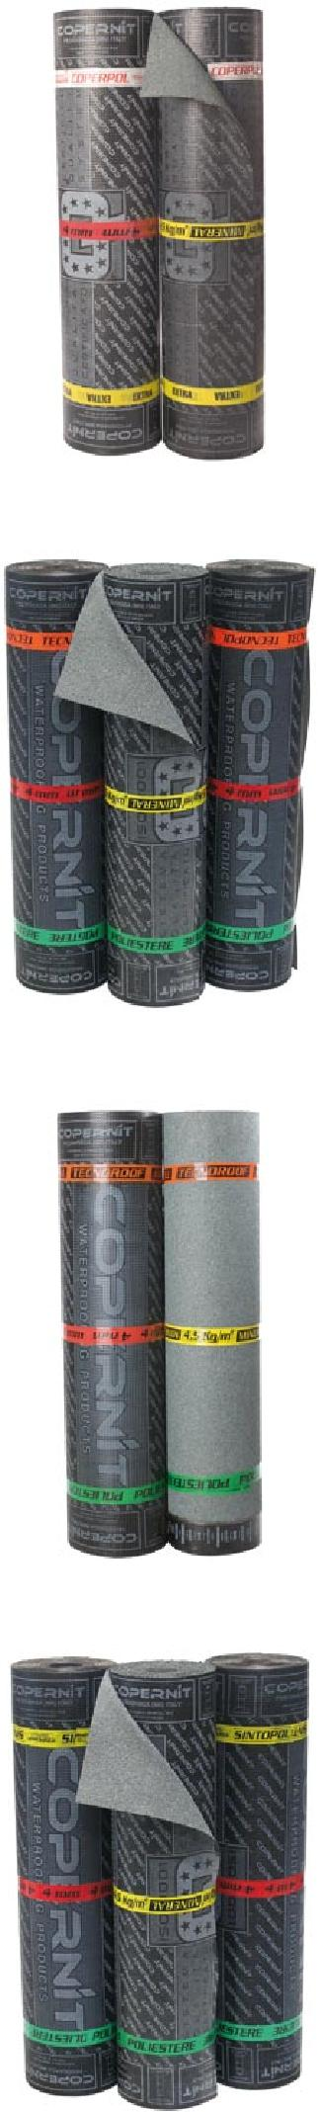

10



|  |  |  |  |
| --- | --- | --- | --- |
|  |  |  |  |
|  | **** | Coperpol Extra | -35°C |
|  |  | Coperpol Extra Mineral | -35°C |
|  | **** | Coperpol 18 HP | -25°C |
|  |  | Coperpol 18 HP Mineral | -25°C |
|  | **** | Coperpol | -20°C |
|  |  | Coperpol Mineral | -20°C |
|  | **** | Tecnopol | -15°C |
|  |  | Tecnopol Mineral | -15°C |
|  | **** | Astropol | -10°C |
|  |  | Astropol Mineral | -10°C |
|  |  | Astropol Mineral Colorato | -10°C |
|  |  | Astropol 25 | -10°C |
|  |  | Astropol 30 | -10°C |
|  |  | Astropol Antiradice | -10°C |
|  |  | Astropol Tex | -10°C |
|  |  | Astropol Biarmato | -10°C |
|  | **** | Starpol | -10°C |
|  |  | Starpol Mineral | -10°C |
|  | **** | Tecnoroof | -10°C |
|  |  | Tecnoroof Mineral | -10°C |
|  | **** | Fiberpol | -5°C |
|  |  | Fiberpol Mineral | -5°C |
|  | **** | Sintopol | -5°C |
|  |  | Sintopol Mineral | -5°C |
|  |  | Sintopol Mineral Colorato | -5°C |
|  |  | Sintopol Tex | -5°C |
|  | **** | Idropol | 0°C |
|  |  | Idropol Mineral | 0°C |
|  |  |  |  |

|  |  |  |  |  |
| --- | --- | --- | --- | --- |
|  |  |  | **I PRODOTTI PRODUCTS** |  |

|  |  |  |  |  |
| --- | --- | --- | --- | --- |
|  | 11 |  |  |  |

|  |  |  |  |  |
| --- | --- | --- | --- | --- |
|  |  |  |  |  |

|  |  |  |  |  |
| --- | --- | --- | --- | --- |
|  |  |  |  |  |

**SBS POLIESTERE SBS POLYESTER**

|  |  |  |
| --- | --- | --- |
| **** | Coperflex | -25°C |
|  | Coperflex Mineral | -25°C |
| **** | Astroflex | -20°C |
|  | Astroflex Mineral | -20°C |
| **** | Fiberflex | -15°C |
|  | Fiberflex Mineral | -15°C |
| **** | Arcoflex | -10°C |
|  | Arcoflex Mineral | -10°C |

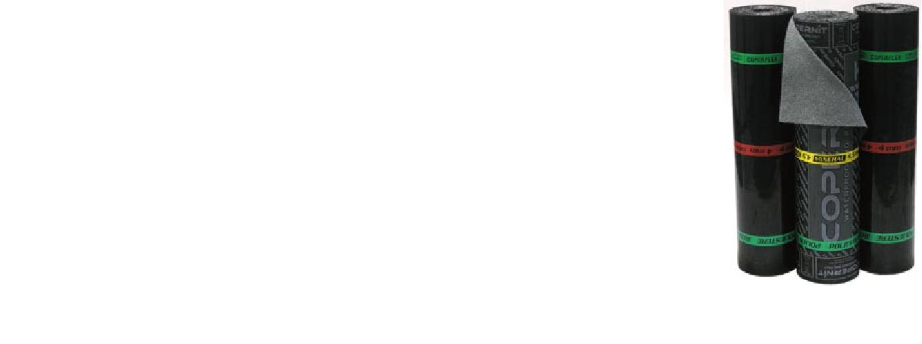

**APP VELO VETRO APP GLASS FIBRE**

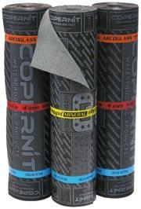

|  |  |  |
| --- | --- | --- |
| **** | Arcoglass | -5°C |
| **** | Sintoglass | 0°C |
|  | Sintoglass Mineral | 0°C |

**MEMBRANE PER APPLICAZIONI SPECIALI MEMBRANES FOR SPECIAL APPLICATIONS**



|  |  |  |
| --- | --- | --- |
| **** | Fibervap | -5°C |
|  | Barriera al vapore armata con | |
|  | lamina di alluminio |  |
|  | Vapour barrier reinforced with | |
|  | aluminium lamina |  |
| **** | Timberpol | -15°C |
|  | Sottostrato per fissaggio mecca- | |
|  | nico, strato di separazione | |
|  | Underlay for mechanical faste- | |
|  | ning, separation underlay | |
| **** | Timberpol Tex | -25°C |

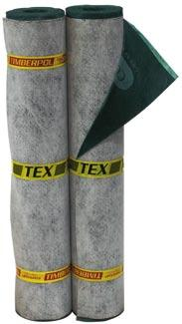

Sottotegola per tetti in legno

Under-tile for wooden roofs

**MEMBRANE AUTOADESIVE SELF-ADHESIVE MEMBRANES**

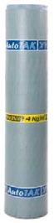

|  |  |  |
| --- | --- | --- |
| **** | Autotak | -15°C |
| **** | Autotak Mineral | -15°C |

|  |  |  |
| --- | --- | --- |
| **I PRODOTTI PRODUCTS** | 12 |  |
|  |  |

**MEMBRANE TERMOADESIVE THERMO-ADHESIVE MEMBRANES**

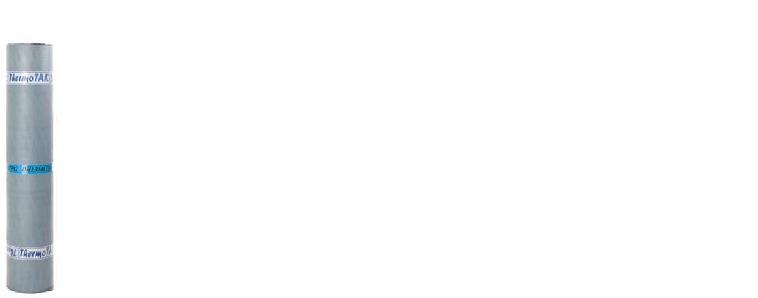

|  |  |  |
| --- | --- | --- |
| **** | Thermotak P | -15°C |
| **** | Thermotak V | -15°C |

**MEMBRANE PER ISOLAMENTO ACUSTICO SOUNDPROOFING MEMBRANES**

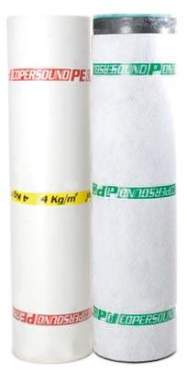

** **Copersound P

Isolamento acustico per pavimento Soundproofing floor insulation

** **Copersound PE

Isolamento acustico per pareti Soundproofing wall insulation

**MEMBRANE AUTOPROTETTE SELF-PROTECTED MEMBRANES**

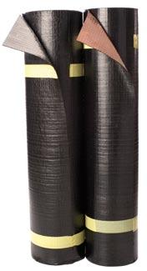

** **Alugum

Rivestimento con lamina di alluminio Covering with aluminium lamina

** **Coppergum

Rivestimento con lamina di rame Covering with copper lamina

**TEGOLE BITUMINOSE BITUMINOUS TILES**

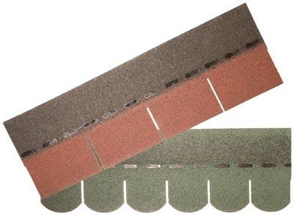

** **Number One 4 TAB

* Number One 6 TAB

|  |  |  |  |  |
| --- | --- | --- | --- | --- |
|  |  |  |  |  |

|  |  |  |  |  |
| --- | --- | --- | --- | --- |
|  |  | 13 | **LE FINITURE** |  |

|  |  |  |  |  |
| --- | --- | --- | --- | --- |
|  |  |  |  |  |

|  |  |  |  |  |
| --- | --- | --- | --- | --- |
|  |  |  |  |  |

|  |  |  |  |  |
| --- | --- | --- | --- | --- |
|  |  |  | **FINISHES** |  |

**VERDE/GREEN** **GRIGIO NATURALE/NATURAL GREY** **GRIGIO SCURO/GREY H.18**

**BIANCO/WHITE** **ROSSO/RED** **TESTA DI MORO/BROWN**

**BORGOGNA/BOURGOGNE** **NERO/BLACK** **SABBIA/SAND**

**FILM LUCIDO/FILM** **TEX/TEX** **TALCO/TALC**

|  |  |  |  |  |  |  |  |  |  |  |
| --- | --- | --- | --- | --- | --- | --- | --- | --- | --- | --- |
| **ISOLANTI** | |  | 14 |  |  |  |  |  |  |  |
|  |  |  |  |  |  |  |  |  |
| **INSULATING** | | | |  |  |  |  |  |  |  |
|  |  |  |  |  | | |  | |  |  |
|  |  |  |  |  |  |  |  |  |  |  |
|  |  | FESCO BOARD | | Pannello isolante per coperture in roccia vulcanica espansa | | | | |  |  |
|  |  | densità 150 kg/mc | | | |  |  |  |
|  |  |  |  | Volcanic ore insulation panel with a density of 150 Kg/m3 | | | | |  |  |
|  |  |  |  |  | | |  | |  |  |
|  |  |  |  | Pannello isolante di colore giallo superficie liscia con pelle | | | | |  |  |
|  |  |  |  | DIR | | Finitura laterale a bordi dritti | |  |  |  |
|  |  |  |  |  |  | dimensione pannello cm. 60x125 | | |  |  |
|  |  |  |  | BAT | | Finiture laterali a battente L | |  |  |  |
|  |  |  |  |  |  | dimensioni pannello cm. 60x125 | | |  |  |
|  |  |  |  | INC | | Finiture laterali a incastro D | |  |  |  |
|  | POLISTIRENE ESTRUSO | | |  |  | dimensioni pannello cm. 60x280 | | |  |  |
|  | Smooth surface yellow insulation panel. | | | | |  |  |
|  | EXTRUDED POLYSTYRENE BOARDS | | |  |  |
|  | Available with following edge types : | | | |  |  |  |
|  |  |  |  | DIR | | Side finish with straight cut edges; | | |  |  |
|  |  |  |  |  |  | Boards are size 60x125 cm | |  |  |  |
|  |  |  |  | BAT | | Side finish with rebated L -shape edges; | | |  |  |
|  |  |  |  |  |  | Boards are size 60x125 cm | |  |  |  |
|  |  |  |  | INC | | Side finish with T/G edges; | |  |  |  |
|  |  |  |  |  |  | Boards are size 60x280 cm | |  |  |  |
|  |  |  |  |  |  | |  | |  |  |
|  |  |  |  | B | Pannello isolante per pareti costituito da poliuretano rigido | | | |  |  |
|  |  |  |  |  | espanso fra due supporti di carta bitumata da 85 g/mq | | | |  |  |
|  |  |  |  |  | dimensione pannello cm. 60x120 | | |  |  |  |
|  |  |  |  | C | Pannello isolante per coperture e pavimenti costituito | | | |  |  |
|  |  |  |  |  | da poliuretano rigido espanso fra due supporti di cartonfeltro | | | |  |  |
|  |  | POLIURETANO | |  | bitumato da 300 g/mq | | |  |  |  |
|  |  |  | dimensione pannello cm. 60x120 | | |  |  |  |
|  | POLYURETHANE BOARDS | | |  |  |  |  |
|  | B | Wall insulation board made of rigid polyurethane foam lined on | | | |  |  |
|  |  |  |  |  |  |
|  |  |  |  |  | both sides with 85g/m2 bitumen paper | | | |  |  |
|  |  |  |  |  | boards are size 60x120 cm | | |  |  |  |
|  |  |  |  | C | Floor insulation board made of rigid polyurethane foam lined on | | | |  |  |
|  |  |  |  |  | both sides with 300g/m2 bitumen felt paper | | | |  |  |
|  |  |  |  |  | boards are size 60x120 cm | | |  |  |  |
|  |  |  |  |  | | |  | |  |  |
|  |  |  |  | Pannello in lana di roccia ad alta densità con una superficie rivestita da | | | | |  |  |
|  |  |  |  | bitume che consente una rapida e sicura applicazione delle membrane | | | | |  |  |
|  |  |  |  | impermeabili mediante sfiammatura. | | | |  |  |  |
|  |  |  |  | Migliora le performance termiche e acustiche della copertura | | | | |  |  |
|  |  |  |  | dimensione pannello cm. 100x120 | | | |  |  |  |
|  |  |  |  | Materassino in lana di roccia rivestito su un lato con carta kraft polite- | | | | |  |  |
|  |  |  |  | nata. | |  |  |  |  |  |
|  |  | LANA DI ROCCIA | | Ideale per l’isolamento dell’ultimo solaio e sottotetti non abitati. | | | | |  |  |
|  |  | dimensione pannello cm. 120x1000 | | | |  |  |  |
|  | ROCK MINERAL WOOL PANELS | | |  |  |  |
|  | High density rock mineral wool panels with one-side bitumen coating for | | | | |  |  |
|  |  |  |  |  |  |
|  |  |  |  | quick and safe torch bonding of bituminous waterproofing layers. | | | | |  |  |
|  |  |  |  | These panels are designed to provide excellent thermal and acoustic | | | | |  |  |
|  |  |  |  | insulation in all roofing applications. | | | |  |  |  |
|  |  |  |  | Panels are size 100x120 cm | | | |  |  |  |
|  |  |  |  | Rockwool matting with poly-coated Kraft paper on one side. | | | | |  |  |
|  |  |  |  | Ideal for the insulation of the uninhabited top floors or lofts. | | | | |  |  |
|  |  |  |  | Panel dimension 120x1000 cm | | | |  |  |  |
|  |  |  |  |  | | |  | |  |  |
|  |  |  |  | Materassino in lana di vetro trattato con resine termoindurenti rivestito | | | | |  |  |
|  |  |  |  | su una faccia con carta kraft o con polipropilene alluminato. | | | | |  |  |
|  |  | LANA DI VETRO | | Dimensione rotolo cm. 120x1900 | | | |  |  |  |
|  |  | Resin-stabilized glass wool mats, lined on one side with Kraft paper | | | | |  |  |
|  |  | GLASS WOOL MATS | |  |  |
|  |  |  |  | or with Alu/PP multilayer. | | | |  |  |  |
|  |  |  |  | Roll size 120x1900 cm | | | |  |  |  |
|  |  |  |  |  | | |  |  |  |  |
|  |  |  |  | ISOLANTI | | |  | MEMBRANE BITUMINOSE DI |  |  |
|  |  |  |  | • Polistirene espanso | | |  | ACCOPPIAMENTO |  |  |
|  | TERMOISOLANTI ACCOPPIATI | | | • Polistirene estruso | | |  | • Velo vetro |  |  |
|  | • Poliuretano cc | | |  | • Poliestere |  |  |
|  | A MEMBRANE BITUMINOSE | | |  |  |  |
|  | • Lana di roccia | | |  | • Poliestere ardesiato |  |  |
|  | FACTORY BONDED THERMAL | | | THERMAL INSULATION MATE- | | |  |  |  |
|  |  | BITUMINOUS MEMBRANE |  |  |
|  | INSULATION/ WATERPROOFING | | | RIALS | | |  | TYPES |  |  |
|  |  | MEMBRANE | | • Expanded polystyrene | | |  | • Glass or Polyester reinforced, |  |  |
|  |  | • Extruded polystyrene | | |  |  |  |
|  |  |  |  |  | sand or slate finish |  |  |
|  |  |  |  | • Polyurethane cfc free | | |  |  |  |
|  |  |  |  | • Mineral wool fibre | | |  |  |  |  |
|  |  |  |  |  |  |  |  |  |  |  |

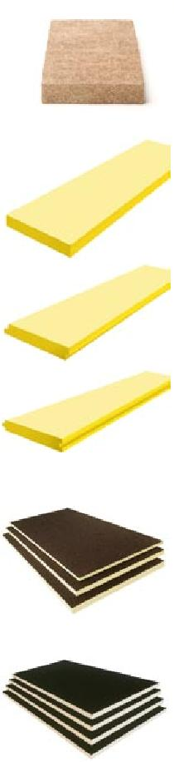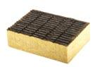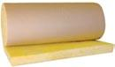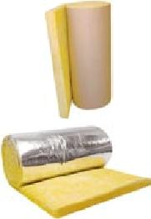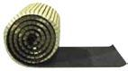

|  |  |  |  |  |  |  |
| --- | --- | --- | --- | --- | --- | --- |
|  |  |  | 15 |  | **ACCESSORI** |  |

|  |  |  |  |  |  |  |
| --- | --- | --- | --- | --- | --- | --- |
|  |  |  |  |  |  |  |

|  |  |  |  |  |  |
| --- | --- | --- | --- | --- | --- |
|  |  |  |  | **ACCESSORIES** |  |

|  |  |  |  |  |
| --- | --- | --- | --- | --- |
|  |  |  |  |  |

|  |  |  |  |  |  |  |
| --- | --- | --- | --- | --- | --- | --- |
|  |  |  |  |  |  |  |

|  |  |  |  |  |
| --- | --- | --- | --- | --- |
|  |  | POLIESTERE GEOTESSILE | poliestere a fibra lunga per protezione membrane per applicazioni |  |

|  |  |  |  |  |  |
| --- | --- | --- | --- | --- | --- |
|  |  |  | contro terra |  |  |

|  |  |  |  |  |
| --- | --- | --- | --- | --- |
|  |  | GEOTEXTILE POLYESTER | Long fibre polyester mat designed for protection of waterproofing |  |

|  |  |  |  |  |
| --- | --- | --- | --- | --- |
|  |  |  | layers in soil backfill applications |  |

|  |  |  |  |  |
| --- | --- | --- | --- | --- |
|  |  |  |  |  |

|  |  |  |  |  |
| --- | --- | --- | --- | --- |
|  |  | CARTONFELTRO BITUMATO CILINDRATO | carta feltro impregnata di bitume ossidato |  |

|  |  |  |  |  |
| --- | --- | --- | --- | --- |
|  |  | BITUMEN FELT PAPER | Felt paper saturated with oxidised bitumen |  |

|  |  |  |  |  |
| --- | --- | --- | --- | --- |
|  |  |  |  |  |

|  |  |  |  |  |
| --- | --- | --- | --- | --- |
|  |  |  | rotolo di membrana bugnata in polietilene per la protezione drenante |  |

|  |  |  |  |  |
| --- | --- | --- | --- | --- |
|  |  | COPERLINE | di muri controterra e fondazioni |  |

|  |  |  |  |  |
| --- | --- | --- | --- | --- |
|  |  |  | Dimpled HDPE rolls designed to provide drainage in below ground |  |

|  |  |  |  |  |
| --- | --- | --- | --- | --- |
|  |  | COPERLINE |  |  |

|  |  |  |  |  |
| --- | --- | --- | --- | --- |
|  |  |  | applications as retaining walls and foundations |  |

|  |  |  |  |  |
| --- | --- | --- | --- | --- |
|  |  |  |  |  |

|  |  |  |  |  |  |
| --- | --- | --- | --- | --- | --- |
|  |  |  | Panel dimension 60x280 |  |  |

|  |  |  |  |  |  |
| --- | --- | --- | --- | --- | --- |
|  |  |  |  |  |  |

|  |  |  |  |  |  |
| --- | --- | --- | --- | --- | --- |
|  |  | TELI SINTETICI TRASPIRANTI | sottotegola traspirante |  |  |

|  |  |  |  |  |
| --- | --- | --- | --- | --- |
|  |  |  | nontessuto di poliestere accoppiato a film riflettente |  |

|  |  |  |  |  |
| --- | --- | --- | --- | --- |
|  |  | BREATHING MEMBRANES | Under-slate breathing membranes of polyester lined on one side with |  |

|  |  |  |  |  |  |
| --- | --- | --- | --- | --- | --- |
|  |  |  | a micro-perforated film |  |  |

|  |  |  |  |  |
| --- | --- | --- | --- | --- |
|  |  |  |  |  |

|  |  |  |  |  |
| --- | --- | --- | --- | --- |
|  |  | CONGLOMERATO BITUMINOSO | conglomerato bituminoso a freddo per interventi di manutenzione |  |

|  |  |  |  |  |  |
| --- | --- | --- | --- | --- | --- |
|  |  |  | stradale |  |  |

|  |  |  |  |  |  |
| --- | --- | --- | --- | --- | --- |
|  |  | ASPHALT REPAIR MIX |  |  |  |

|  |  |  |  |  |
| --- | --- | --- | --- | --- |
|  |  |  | Ready for use cold asphalt and aggregate mix for small road repairs |  |

|  |  |  |  |  |
| --- | --- | --- | --- | --- |
|  |  |  |  |  |

|  |  |  |  |  |
| --- | --- | --- | --- | --- |
|  |  |  |  |  |

|  |  |  |  |  |
| --- | --- | --- | --- | --- |
|  |  | PRIMER | composto a base di bitume ossidato e solventi |  |

|  |  |  |  |  |
| --- | --- | --- | --- | --- |
|  |  | PRIMER | Solvent-base bituminous paint |  |

|  |  |  |  |  |
| --- | --- | --- | --- | --- |
|  |  |  |  |  |

|  |  |  |  |  |
| --- | --- | --- | --- | --- |
|  |  | PRIMER BASE ACQUA | composto a base di bitume ossidato senza solventi |  |

|  |  |  |  |  |
| --- | --- | --- | --- | --- |
|  |  | WATER BASED PRIMER | Solution of oxidised bitumen in water base |  |

|  |  |  |  |  |
| --- | --- | --- | --- | --- |
|  |  |  |  |  |

|  |  |  |  |  |
| --- | --- | --- | --- | --- |
|  |  | ASFALTO A FREDDO | emulsione bituminosa additivata con resine sintetiche per coperture e |  |

|  |  |  |  |  |  |
| --- | --- | --- | --- | --- | --- |
|  |  |  | strutture in cemento |  |  |

|  |  |  |  |  |  |
| --- | --- | --- | --- | --- | --- |
|  |  | COLD ASPHALT |  |  |  |

|  |  |  |  |  |
| --- | --- | --- | --- | --- |
|  |  |  | Bituminous emulsion and resins for concrete roofs and structures |  |

|  |  |  |  |  |
| --- | --- | --- | --- | --- |
|  |  |  |  |  |

|  |  |  |  |  |
| --- | --- | --- | --- | --- |
|  |  |  |  |  |

|  |  |  |  |  |
| --- | --- | --- | --- | --- |
|  |  | BITUME OSSIDATO | impermeabilizzante da usare a caldo |  |

|  |  |  |  |  |
| --- | --- | --- | --- | --- |
|  |  | OXIDISED BITUMEN | Waterproofing material to be used hot |  |

|  |  |  |  |  |
| --- | --- | --- | --- | --- |
|  |  |  |  |  |

|  |  |  |  |  |
| --- | --- | --- | --- | --- |
|  |  | VERNICE ALLUMINIO | vernice protettiva all’alluminio a base solvente |  |

|  |  |  |  |  |
| --- | --- | --- | --- | --- |
|  |  | ALUMINIUM PAINT | Solvent-base reflective aluminium paint |  |

|  |  |  |  |  |
| --- | --- | --- | --- | --- |
|  |  |  |  |  |

|  |  |  |  |  |
| --- | --- | --- | --- | --- |
|  |  | VERNICE ALLUMINIO BASE ACQUA | vernice protettiva all’alluminio senza solventi |  |

|  |  |  |  |  |
| --- | --- | --- | --- | --- |
|  |  | WATER BASE ALUMINIUM PAINT | Solvent-free protective aluminium paint |  |

|  |  |  |  |  |
| --- | --- | --- | --- | --- |
|  |  |  |  |  |

|  |  |  |  |  |
| --- | --- | --- | --- | --- |
|  |  | VERNICI ACRILICHE | idropitture acriliche impermeabilizzanti protettive e decorative per |  |

|  |  |  |  |  |
| --- | --- | --- | --- | --- |
|  |  |  | manti bituminosi. Colori: grigio-rosso |  |

|  |  |  |  |  |
| --- | --- | --- | --- | --- |
|  |  | ACRYLIC PAINT | Protective and decorative acrylic water-base paints designed for use |  |

|  |  |  |  |  |
| --- | --- | --- | --- | --- |
|  |  |  | over bituminous surfaces. Colours available: grey or red |  |

|  |  |  |  |  |
| --- | --- | --- | --- | --- |
|  |  |  |  |  |

|  |  |  |  |  |
| --- | --- | --- | --- | --- |
|  |  | BOCCHETTONI | raccordi per scarichi pluviali |  |

|  |  |  |  |  |
| --- | --- | --- | --- | --- |
|  |  | FLANGES FOR ROOF DRAINS | Flange connection pieces for roof drains |  |

|  |  |  |  |  |  |
| --- | --- | --- | --- | --- | --- |
|  |  |  |  |  |  |

|  |  |  |  |  |  |
| --- | --- | --- | --- | --- | --- |
|  |  | ESALATORI IN DUTRAL | esalatori in dutral |  |  |

|  |  |  |  |  |  |
| --- | --- | --- | --- | --- | --- |
|  |  | DUTRAL ROOF VENTS | Dutral roof vents |  |  |

|  |  |  |  |  |
| --- | --- | --- | --- | --- |
|  |  |  |  |  |

|  |  |  |  |  |
| --- | --- | --- | --- | --- |
|  |  | PARAFOGLIE UNIVERSALI | parafoglie per evitare l’intasamento degli scarichi |  |

|  |  |  |  |  |
| --- | --- | --- | --- | --- |
|  |  | LEAF GUARDS | Leaf retainers to prevent occlusions of drainage pipes |  |

|  |  |  |  |  |
| --- | --- | --- | --- | --- |
|  |  |  |  |  |

|  |  |  |  |  |
| --- | --- | --- | --- | --- |
|  |  | BRUCIATORI | bruciatori professionali per la posa della membrana bituminosa, |  |

|  |  |  |  |  |
| --- | --- | --- | --- | --- |
|  |  |  | corredati da gomma mt. 10 e regolatore |  |

|  |  |  |  |  |
| --- | --- | --- | --- | --- |
|  |  | PROPANE TORCHES | Professional propane torches for bituminous membranes, including |  |

|  |  |  |  |  |  |
| --- | --- | --- | --- | --- | --- |
|  |  |  | 10 m hose and regulator |  |  |

|  |  |  |  |  |  |  |
| --- | --- | --- | --- | --- | --- | --- |
|  |  |  |  |  |  |  |

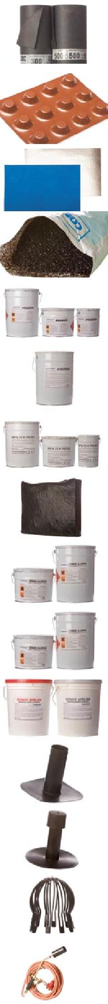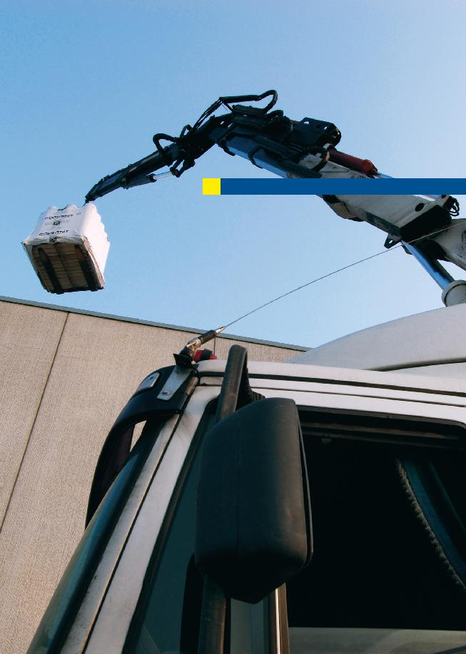

Tempestività nelle risposte e consegna rapida

16

Prompt answers, quick deliveries

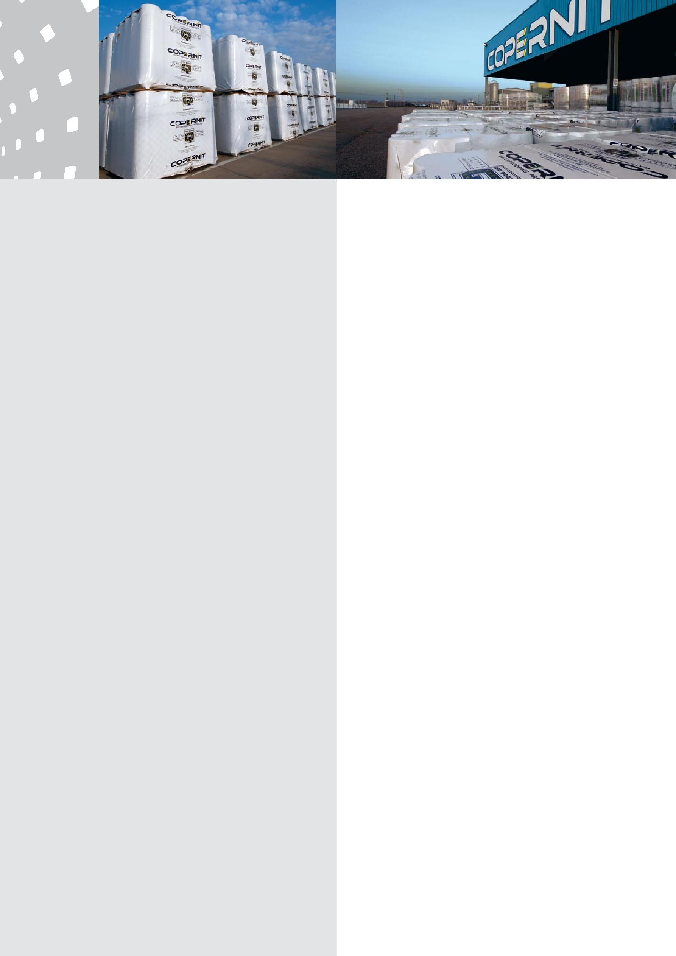

**SERVIZIO E ASSISTENZA SERVICE AND ASSISTANCE**



Tempestività nelle risposte e consegna rapida con servizio di tiro in quota (solo nord Italia), per fornire il prodotto quando, come e dove il cliente lo desidera: questo è lo spirito con cui l’ufficio commerciale Copernit impronta la propria attività quotidiana.

Timely response and deliveries to supply the product when, how and where the customer desires: this is the attitude with which Copernit’s commercial department works every day.

**www.copernit.it**

**info@copernit.it**

|  |
| --- |
| inventivastudio.com |

**COPERNIT** SpA

Via Provinciale Est, 64 - 46020 Pegognaga (MN) - Italy

Tel. +39 0376 554911 - Fax +39 0376 550177

**www.copernit.it - info@copernit.it**